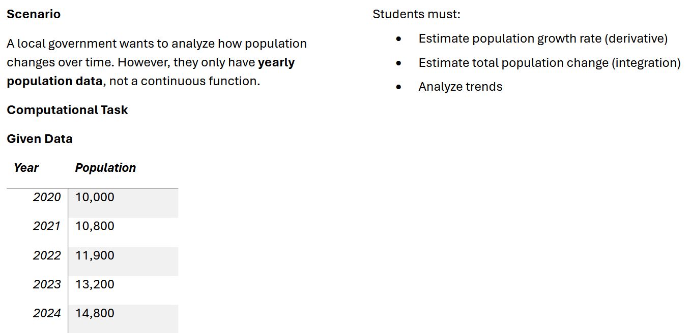

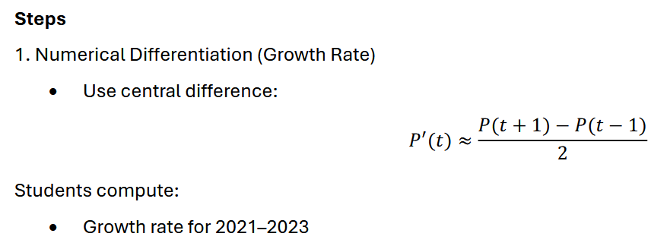

P’(2021) ≈ (11900 – 10000)/2
= 1900/2
P’(2021) = 950

P’(2022) ≈ (13200 – 10800)/2
= 2400/2
P’(2022) = 1200
P’(2023) ≈ (14800 – 11900)/2
= 2900/2
P’(2023) = 1450
Table of Derivatives:
Year | Growth Rate (people/year)
2021 | 950
2022 | 1,200
2023 | 1,450

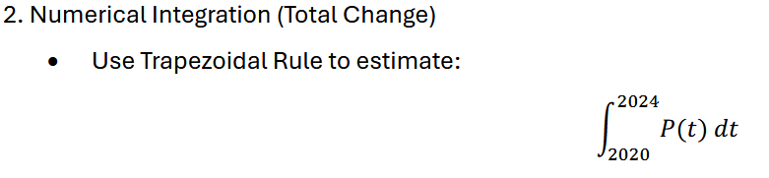
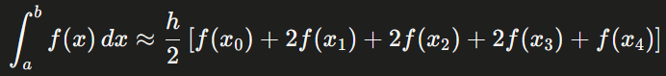

Where:
h = spacing between each data point (in this case, 1 year).
The first and last value are added once.
Every middle value (x1, x2, x3) is multiplied by two
≈ ½ [10000+2(10800)+2(11900)+2(13200)+14800]
= ½ [10000 + 21600 + 23800 + 26400 + 14800]
= ½ * 96600
= 48300
Total accumulated population (2020–2024): 48,300 person-years.
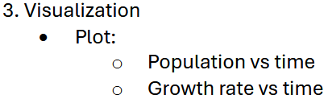

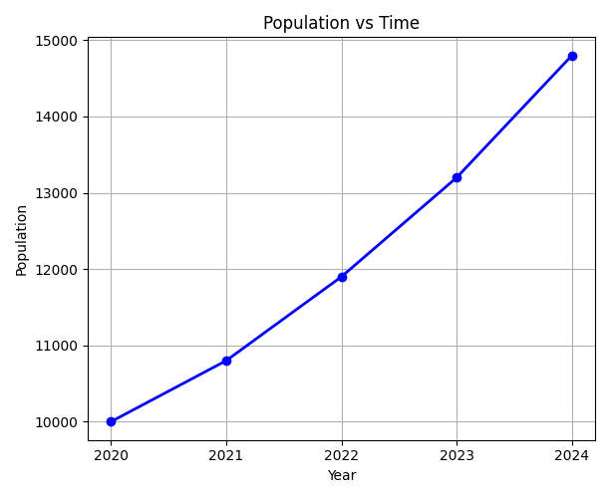

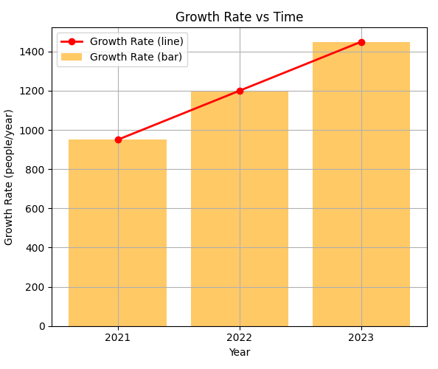

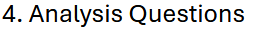
- When did the growth rate accelerate the most?
From what my calculations had concluded, the growth rate of the population accelerated the most in the year 2023 with the rate of 1450. From these numbers as well: 950 1200 1450, the growth, I can say flourished consistently, increasing by 250 each year.
- Is the growth linear or exponential?
The population itself grows exponentially, as seen in the upward-curving plot. However, the growth rate increases linearly, rising by approximately 250 people/year each year.
- Predict population in 2025
Based on the linear trend in growth rates (increasing by 250 per year), the predicted growth rate for 2024 is 1,700 people/year. Therefore, the estimated population in 2025 is approximately 16,500.

This case study analyzed population growth from 2020 to 2024 using numerical methods. Using the central difference formula, the growth rates were estimated at 950, 1,200, and 1,450 people per year for 2021, 2022, and 2023 respectively — increasing by approximately 250 each year, indicating consistent acceleration. The Trapezoidal Rule was then applied to estimate the total accumulated population over the five-year period, yielding 48,300 person-years.
Visual analysis confirmed that the population itself grows exponentially, as seen in the upward-curving population plot, while the growth rate increases linearly. Growth accelerated most heading into 2023, with the highest computed rate of 1,450 people/year. Based on the linear trend in growth rates, the predicted growth rate for 2024 is 1,700 people/year, placing the estimated 2025 population at approximately 16,500.

